**New Hardware**

**Augmented Reality**

Augmented reality is when a device creates a computer generated image over reality, changing a user's view of the real world. Although augmented reality has been around for decades, it has recently risen to the attention of the public with its success on the Nintendo 3DS and the Oculus Rift,.

* The Nintendo 3DS uses its dual cameras to create an image that they are then able to overlay with any image they want. They use these images to create fun, interactive games for the user.

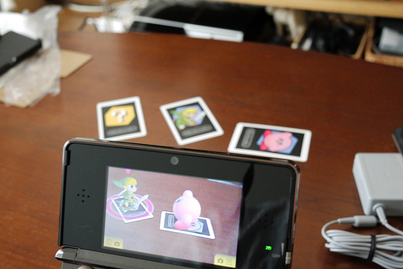

* The Oculus Rift is an immersive new device that uses dual projection to create a 3D image inside a headset. It uses sensors that pick up head movement and changes the image based on head position. It’s being called the future if gaming and already has multiple games in development for it.



**NFC**

Near Field Communication, or NFC for short, is a way for devices like phones or tablets to communicate without physically connecting. Users are able to wave their smartphones or tablets over any NFC capable device and send information without going through multiple steps setting up a connection.

NFC can be used in a variety of useful ways, including

* Sharing photos, games, and info between users
* It can be synced with certain cars, so the car automatically adjusts itself to you
* You can use it as a virtual credit card
* It works as a ticket to concerts and busses

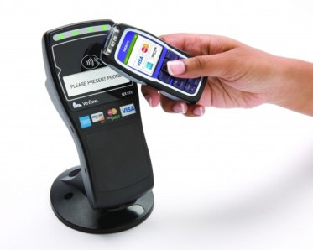

**Trends in Technology**

* It has recently become a necessity for people to feel a sense of community, whether they be on a website or using a device. Comment sections on websites and forums dedicated to your problem make it easier for people to feel like part of a group.
* A few years ago, it became a necessity for websites to not only be designed for desktops, but to also have a functional mobile version. However, we know need to code for more than just desktop and mobile, as people are able to browse from not only their phones and computers, but their TVs, tablets, and gaming consoles. Their also needs to be a seamless flow when browsing between all of them. An option available on one platform needs to be available on all of them.

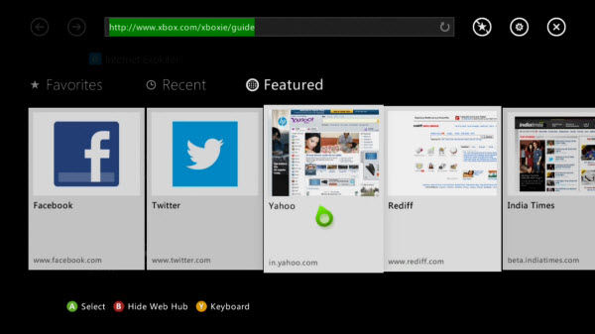

* One of the most important things for a business is for you to get your name out there, and the best way to do that is through social media. Having an active presence on Twitter, Facebook, and other social media platforms is an easy way to have people spread your name for you, and helps build a connection between you and your customers.

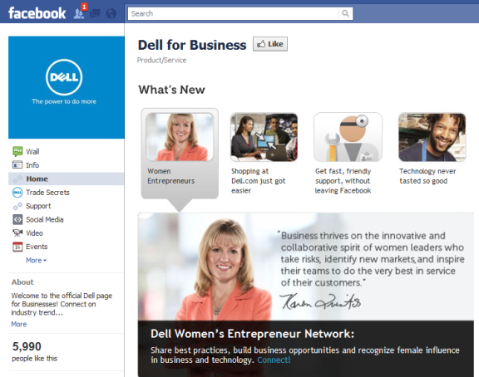

<http://www.4sitestudios.com/emerging-trends-in-digital-for-2013>

<http://inthecrowds.wordpress.com/2011/12/20/emerging-interactive-digital-media-trends-in-2012/>

<http://ideaengineers.sapient.com/technology/8-emerging-trends-in-ecommerce-technology/>

<http://www.t-immersion.com/augmented-reality/future-vision>

<http://static3.businessinsider.com/image/51d1949aecad04ad3e000000/heres-what-happened-when-we-strapped-a-bunch-of-people-into-the-oculus-rift-virtual-reality-headset.jpg>

<http://cdn.slashgear.com/wp-content/uploads/2011/03/verifone_nfc-580x464.jpg>

<http://www.nearfieldcommunication.org/>

<http://www.nintendo.com/3ds/ar-cards>

<http://en.wikipedia.org/wiki/Oculus_Rift>

<http://farm6.static.flickr.com/5136/5478335764_11b184b1c4.jpg>

<http://www.jeffbullas.com/wp-content/uploads/2011/07/Dell-for-Business-Facebook-Page1.png>